**SALESFORCE PROJECT READY**

Entry Level Training and Professional Development Program

**Project :** College Management Application

**Day-1 :**

**Topic:** Create Your Salesforce Developer Org To Get Started

**Milestone/Activities :** Creating Developer account, Account activation, Login to your Salesforce Account

**Description :**

**Creating a developer org in salesforce :**

1. Go to [developers.salesforce.com/](https://developer.salesforce.com/)
2. Click on sign up.
3. On the sign up form, enter the following details :
   1. First name : Porandla & Last name : Abishek Datta
   2. Email : porandlaabishekdatta03@gmail.com
   3. Role : Developer
   4. Company : Chaitanya Institute of Technology and Science
   5. County : India
   6. Postal Code : 506001
   7. Username : abishek@chaitanya.com

Click on sign up after filling these.

**Account Activation**   **:**

* 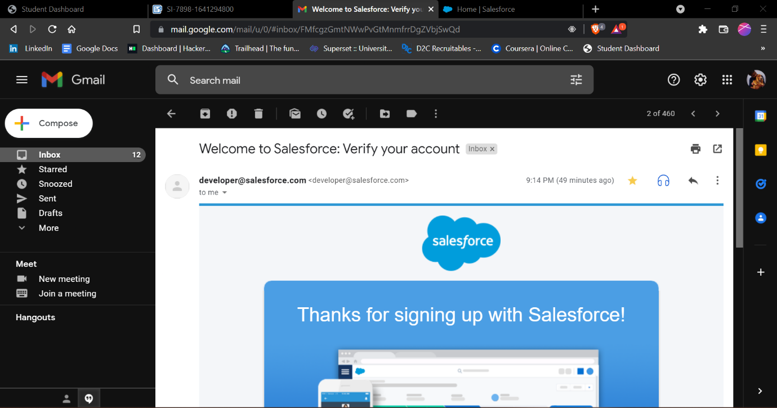
* Verified mail account and activated the account.

**Login to your Salesforce Customer Account :**

➤ Logged into salesforce account using <https://login.salesforce.com/> link.

➤ 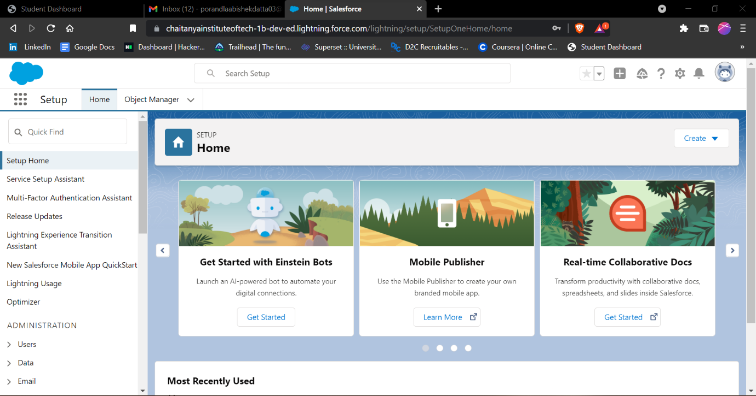

**Day-2 :**

**Topic:** Custom Object Creation

**Milestone/Activities : Create the custom objects for the Application, Create Fields on college object**

**Description :**

Created a College custom object and created Fields for the custom object College.

Fields for College are:

➤ Record Info

➤ College Name

➤ Email

➤ College Fees

➤ Hostel Fees

➤ Capacity of Students

➤ Validation Rules

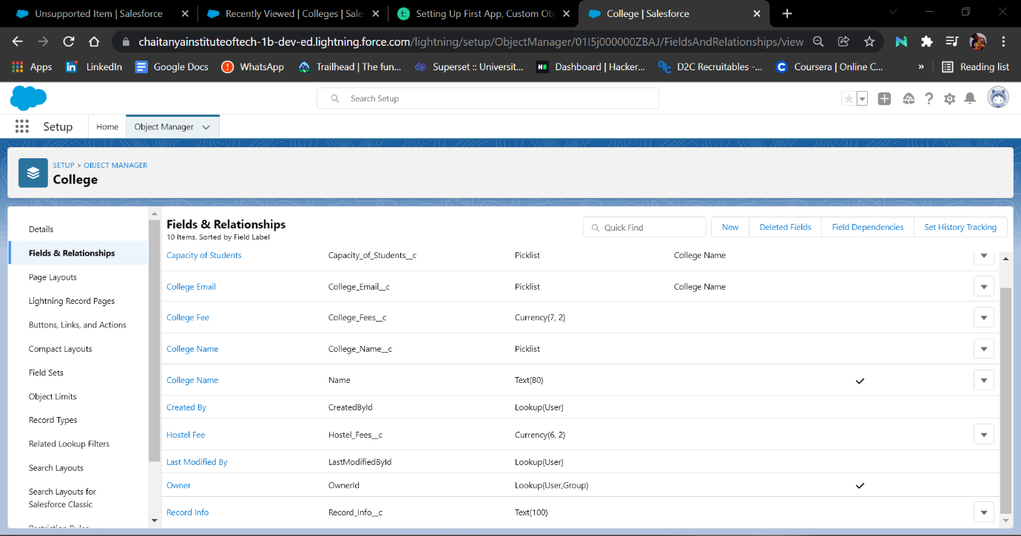

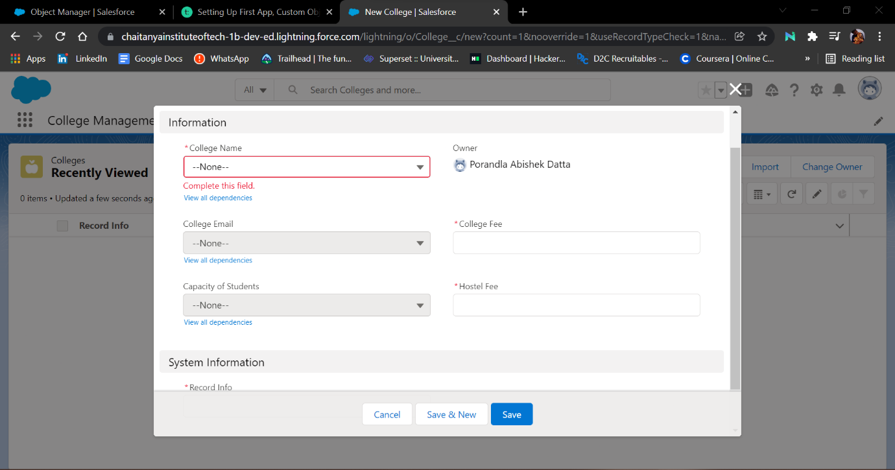

**Day-3 :**

**Topic:** Custom Object Creation

**Milestone/Activities : Create the custom objects for the Application Form, Student, Subject, Create Fields on Application Form object,Student object,Subject object, Adding Business Logic to Applicatioin**

**Description :**

Created a Application Form custom object and created Fields for the custom object Application Form.

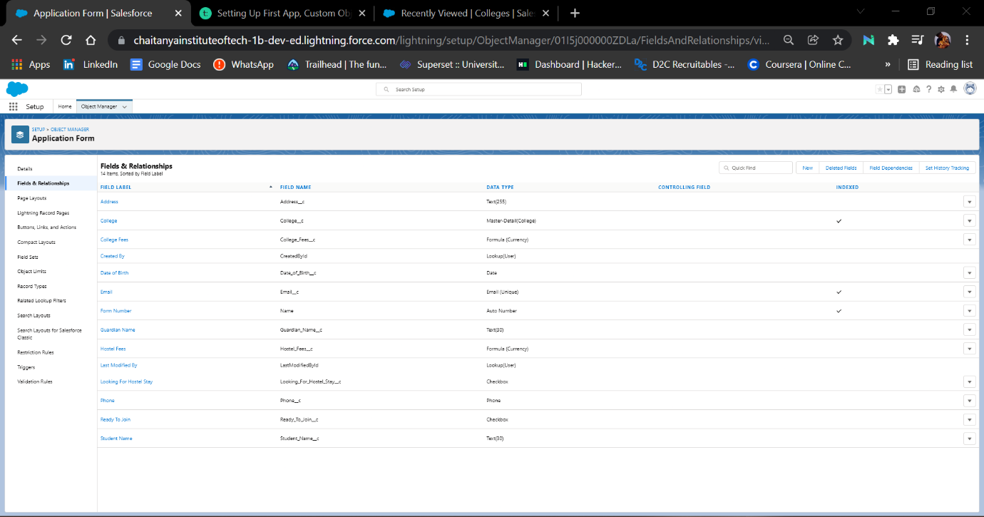

Created a student custom object and created Fields for the custom object student.

**Student Object :**

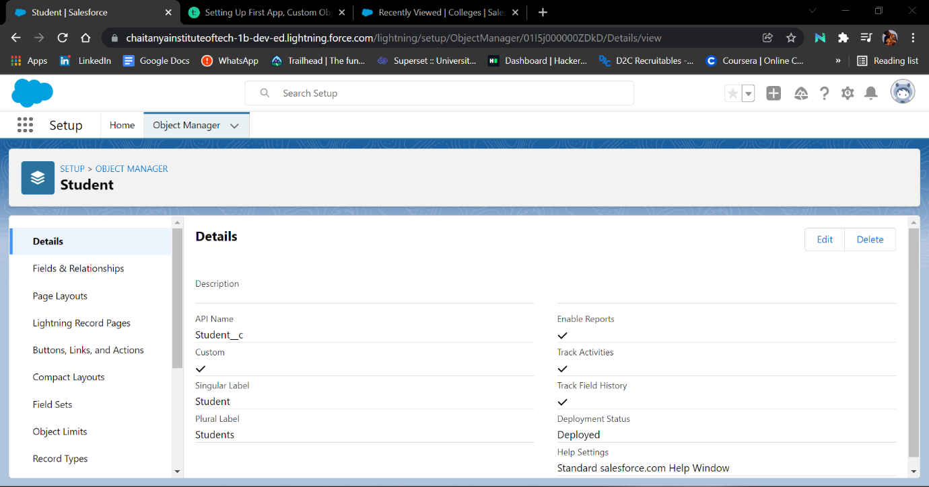

**Student Fields :**

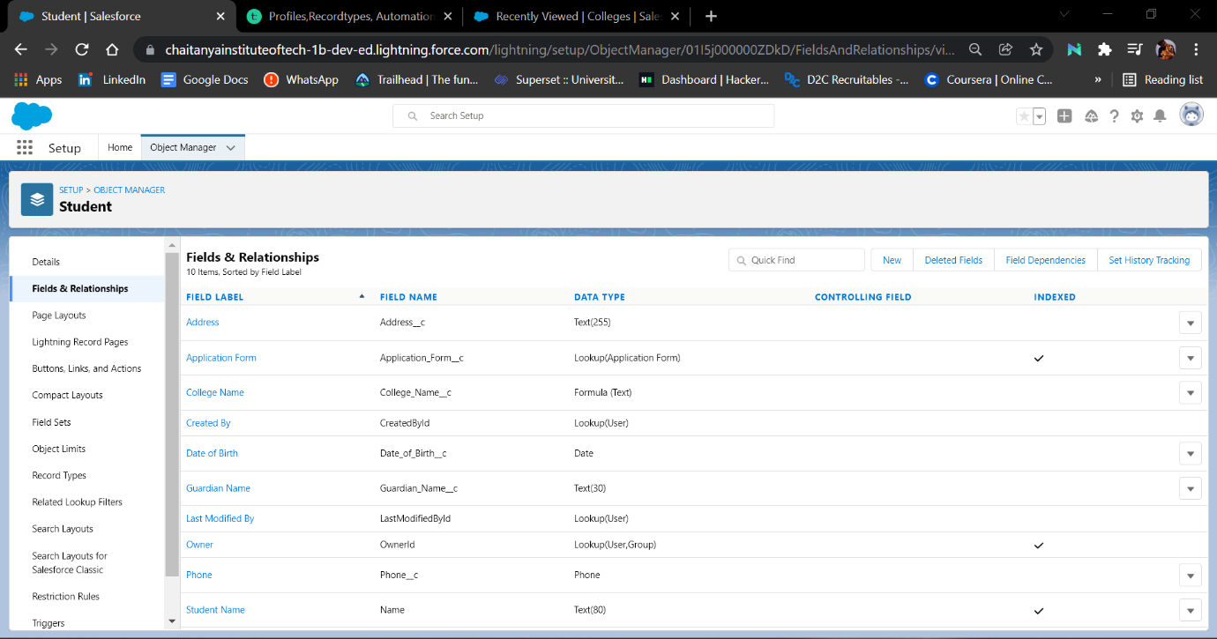

Created a Subject custom object and created Fields for the custom object Subject.

**Subject Object :**

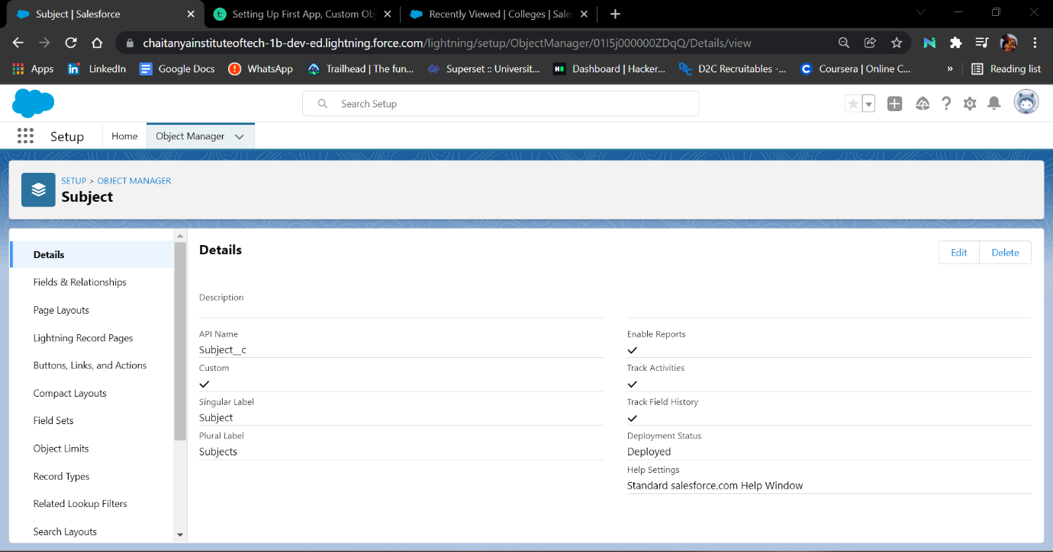

**Subject Fields :**

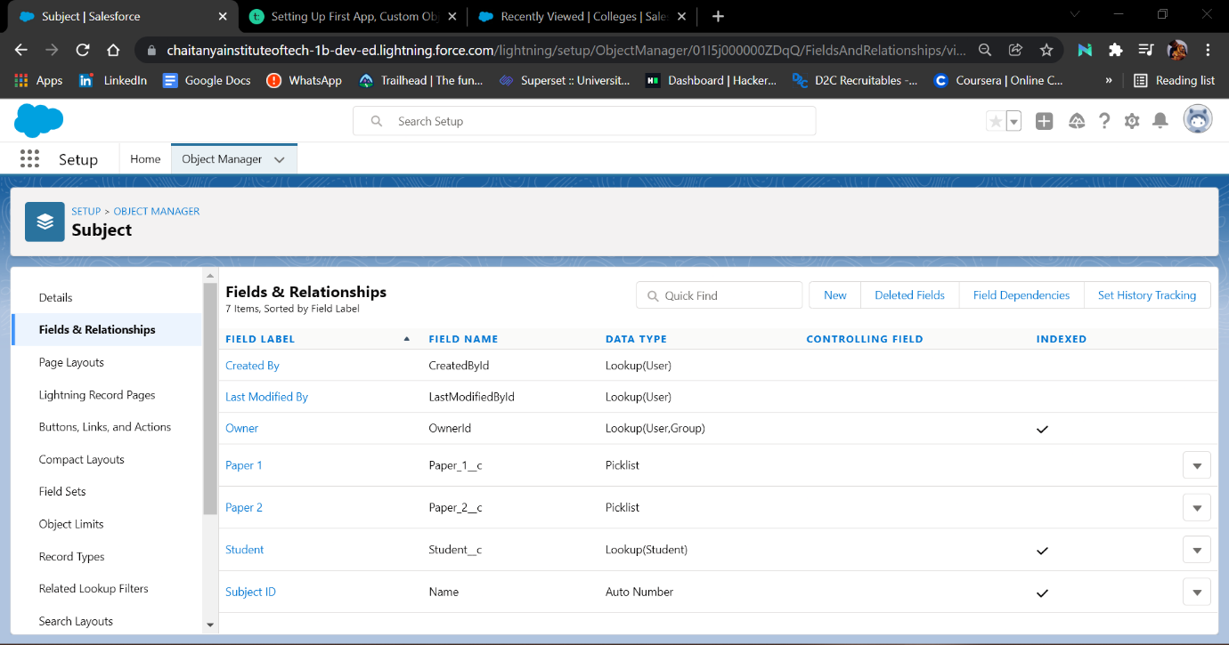

**In Picklist Value sets Created 3 Picklist value sets**

**➤** **College Name**

**➤** **Paper 1**

**➤** **Paper 2**

**Created Global Picklist Values :**

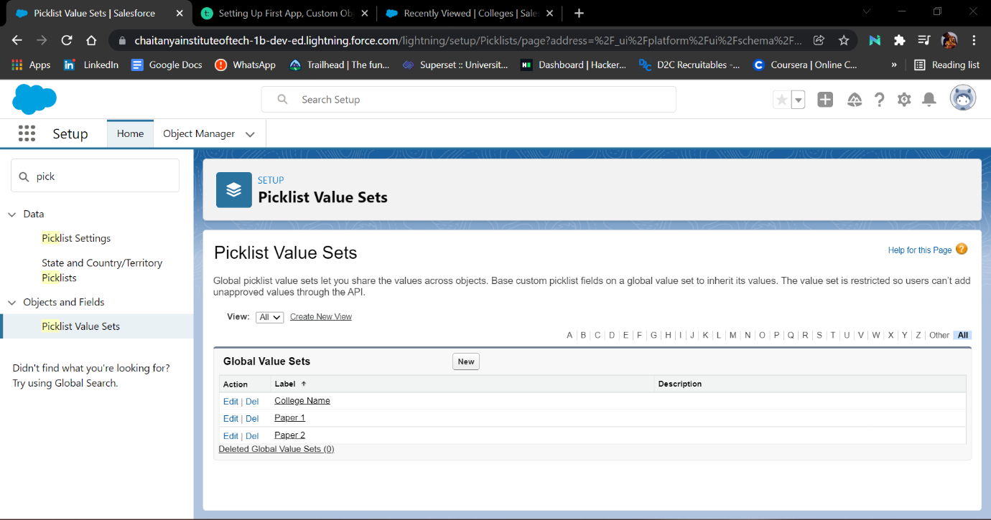

**Creating Validation Rule :**

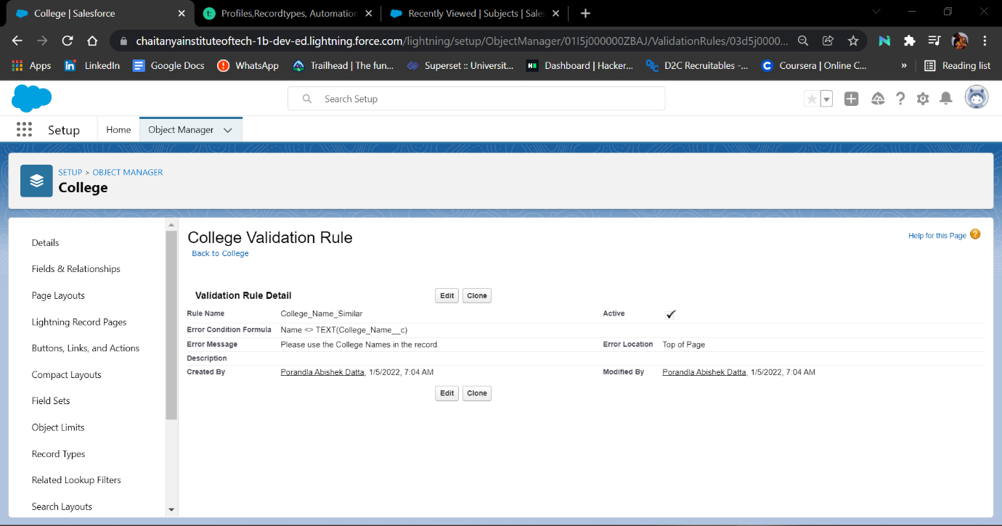

**Creating Field Dependencies :**

**Created field dependencies for college object**

* **controlling filed as college name and depending field is college email.**
* **controlling field as college name and depending field is capacity of students**

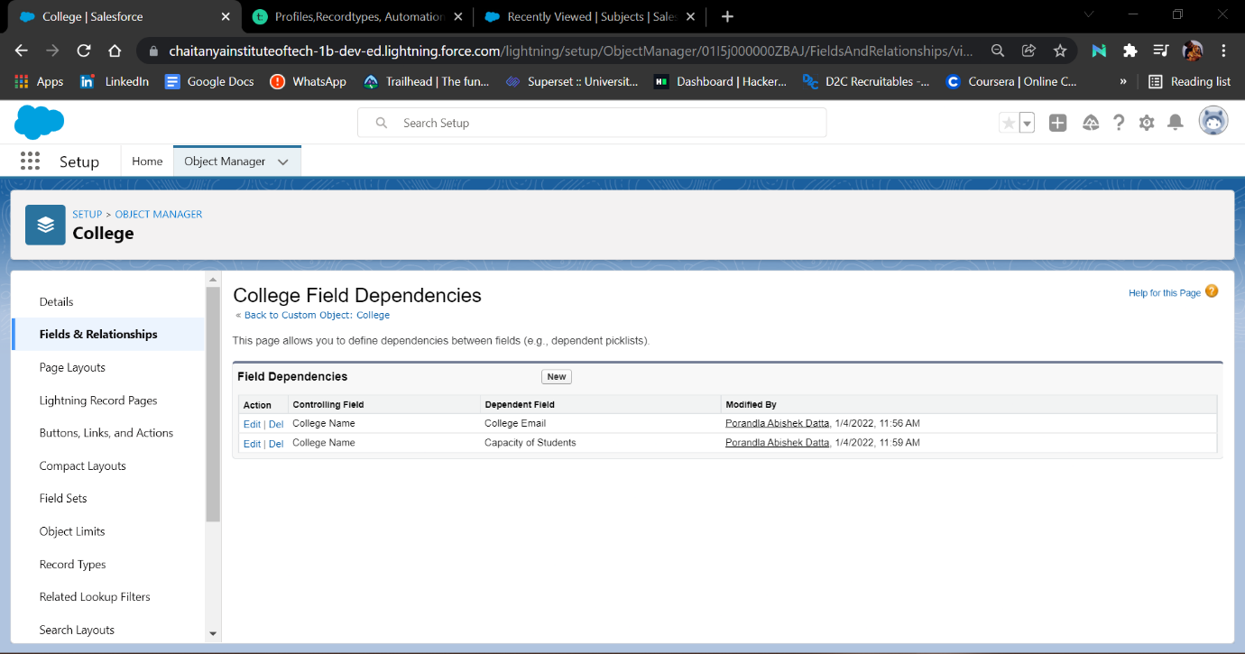

**Day-4 :**

**Topic : Validation Rule**

**Description :**

Created a validation rule on the application form object to stop any modification on the application form once a student record is created.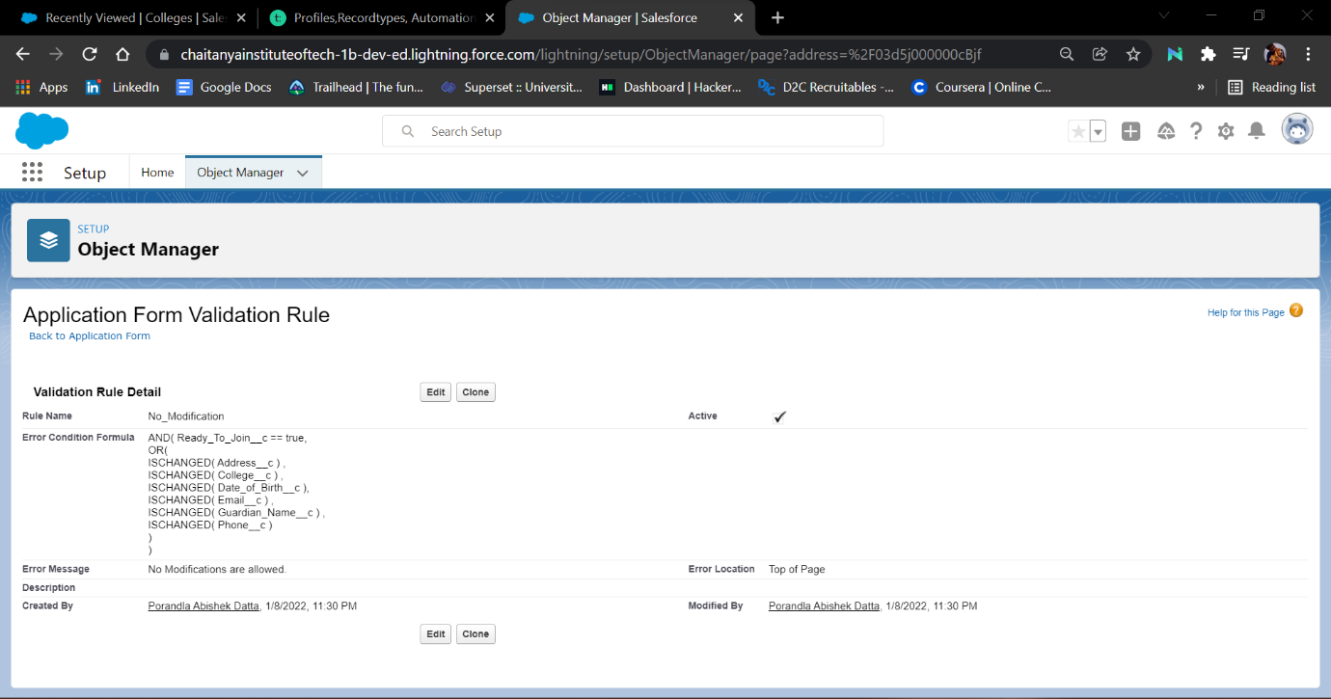

**Day-5 :**

**Topic : Process Automation**

**Description :**

Created an automation process such that when the "ready to join" field is checked on the application form object it will to create the student record automatically with the information specified in the application form record.

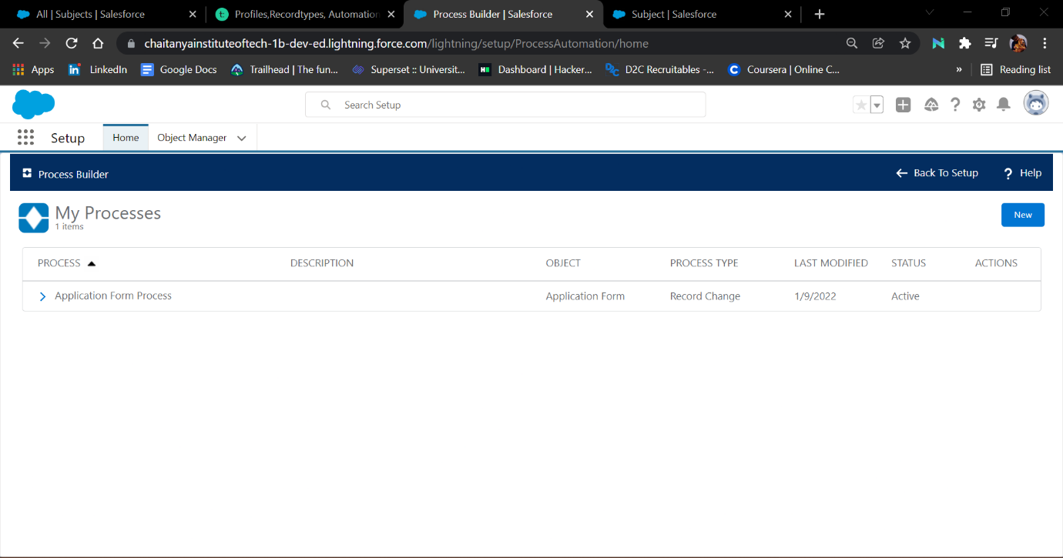

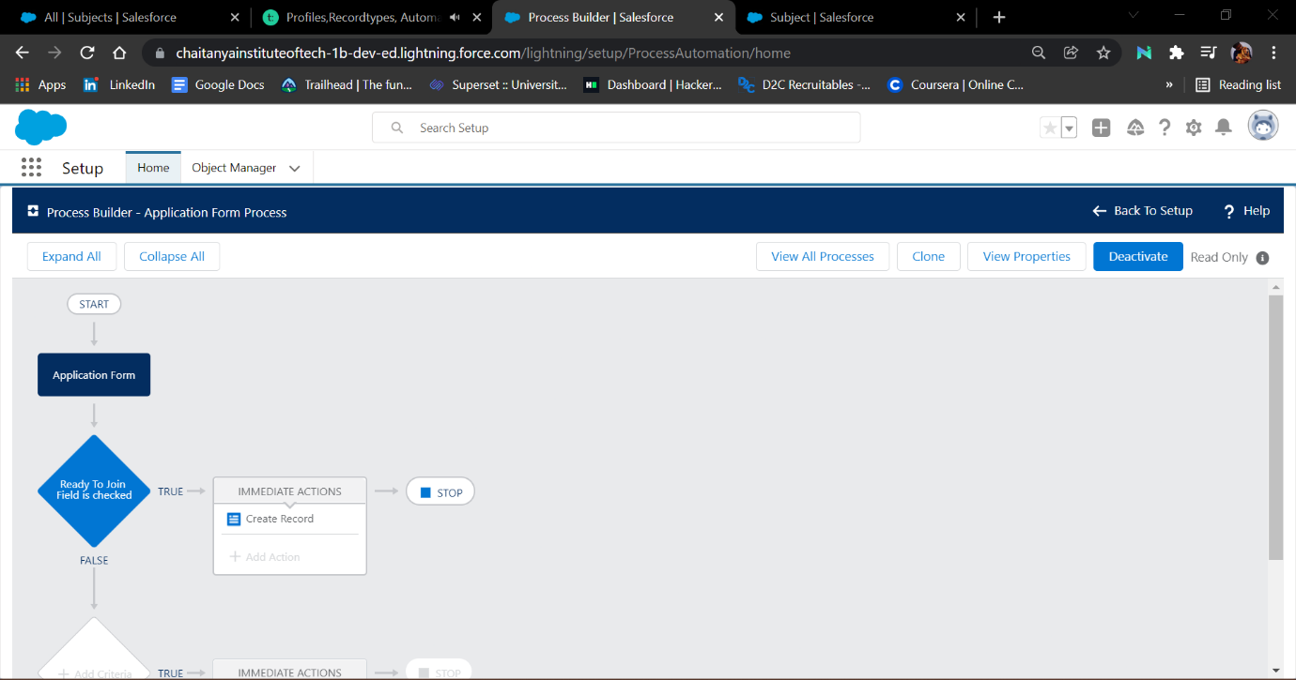

**Day-6 :**

**Topic: Create the student record using flow**

**Milestone/Activities :Adding Business Logic to Application**

**Description :**

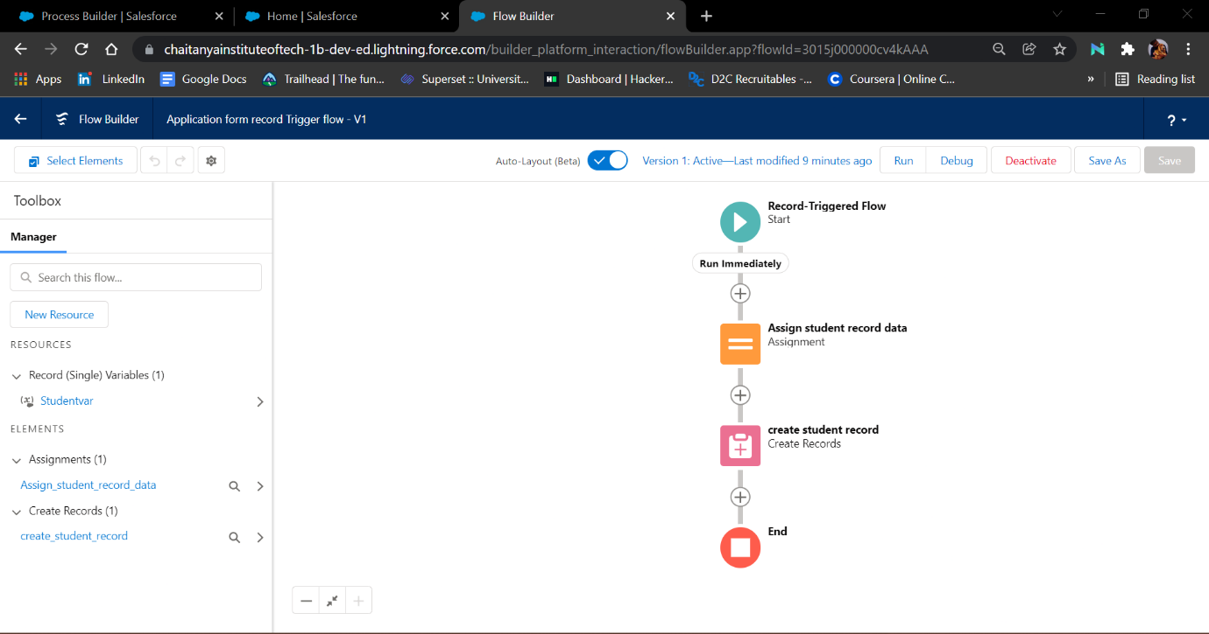

**Day-7 :**

**Topic:** [**BATCH APEX**](https://smartinternz.com/Student/guided_project_workspace/7898#collapse4)

**Milestone/Activities : Create A Batch-apex For Application Form**  **, Create A Scheduler Class**

**Description :**

**created apex batches**

* **Applicationbatchtest**
* **appicationschedule**

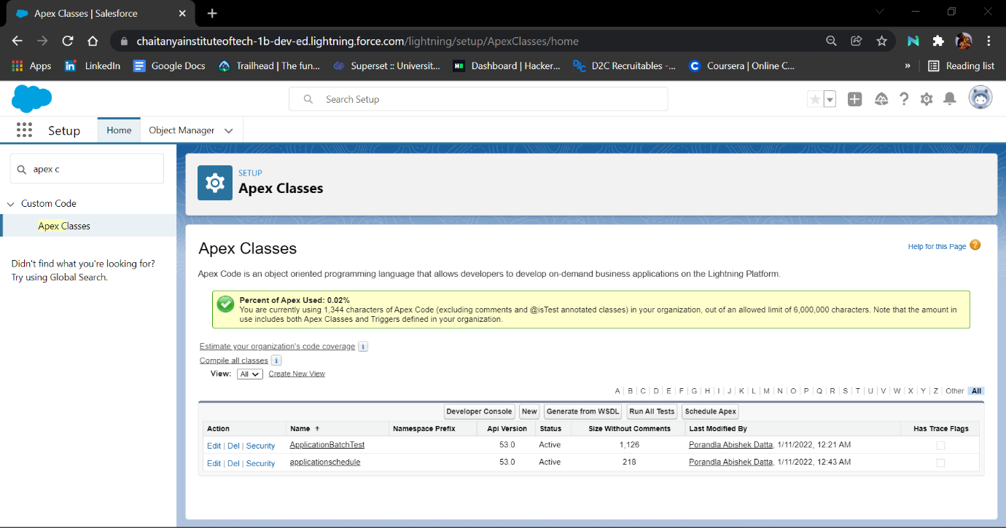

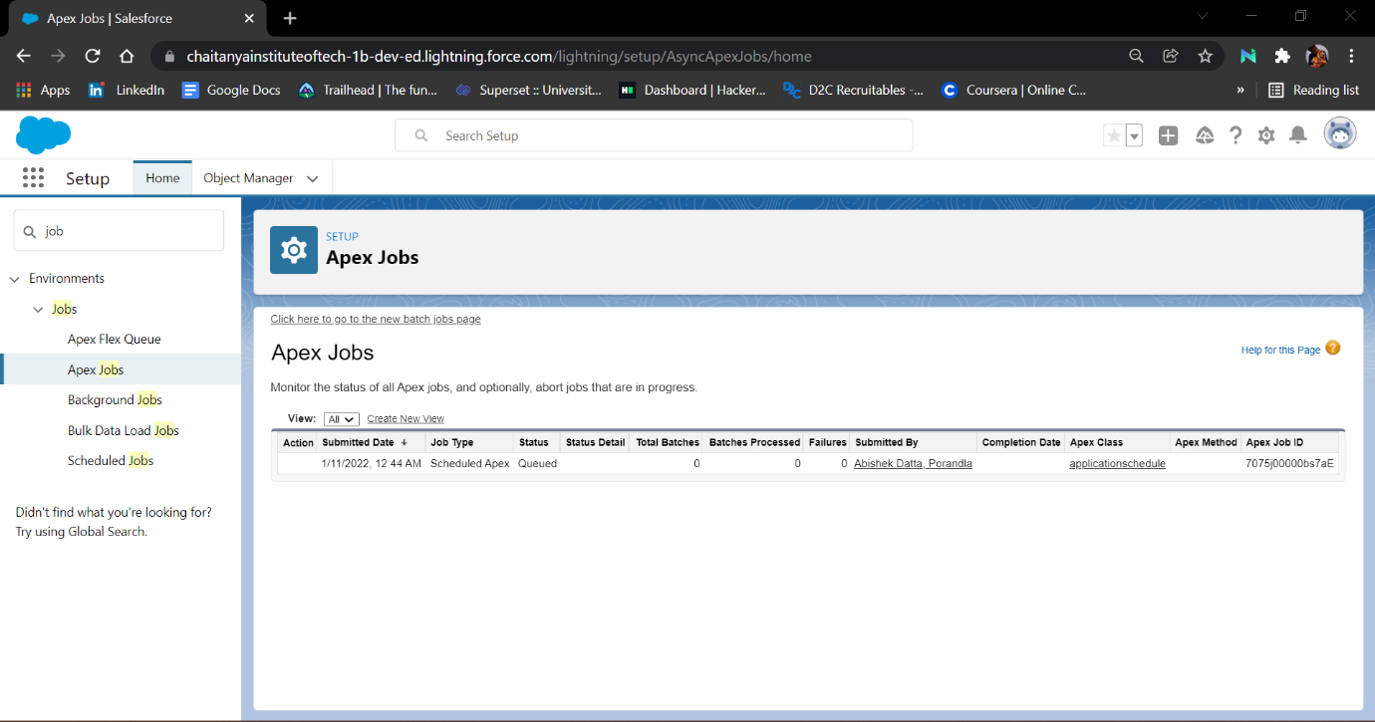

**Developer console codes :**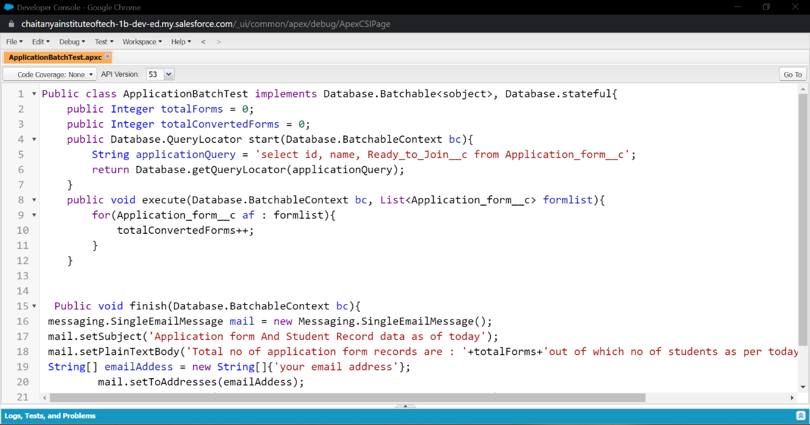

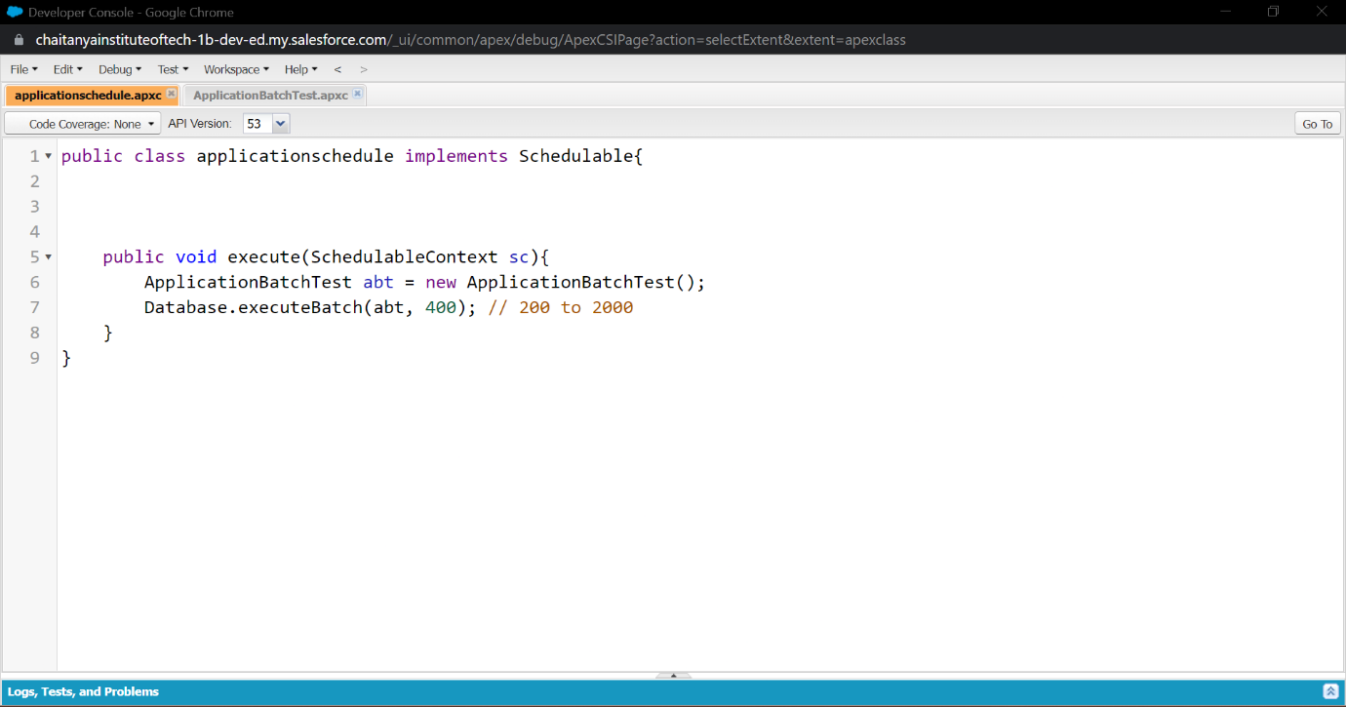

**Scheduled jobs:**

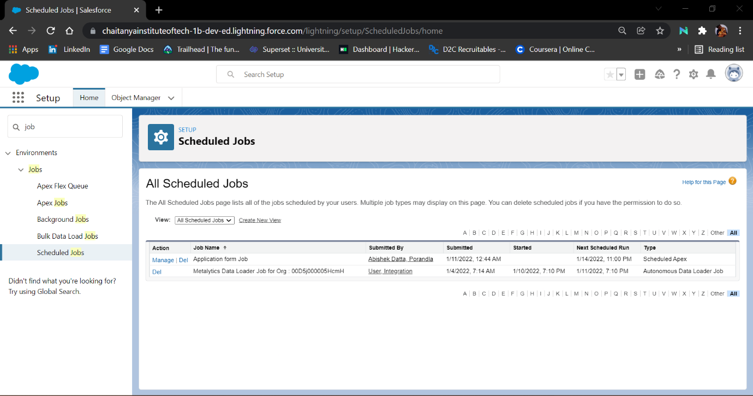

**Day-8:**

**Topic : Lightning Web Components**

**Milestone/Activity :**

* **Creating college data table component( Apex class )**
* **creating college data table component( HTML File )**
* **creating college data table component( Java Script )**
* **creating college data table component( Meta File )**

**Description :**

**Creating college data table component( Apex class ):**

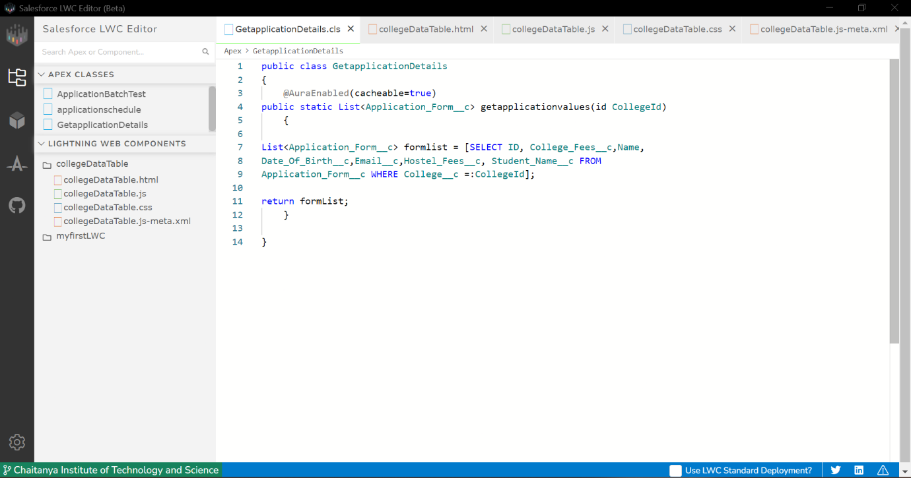

**Creating college data table component( HTML File ) :**

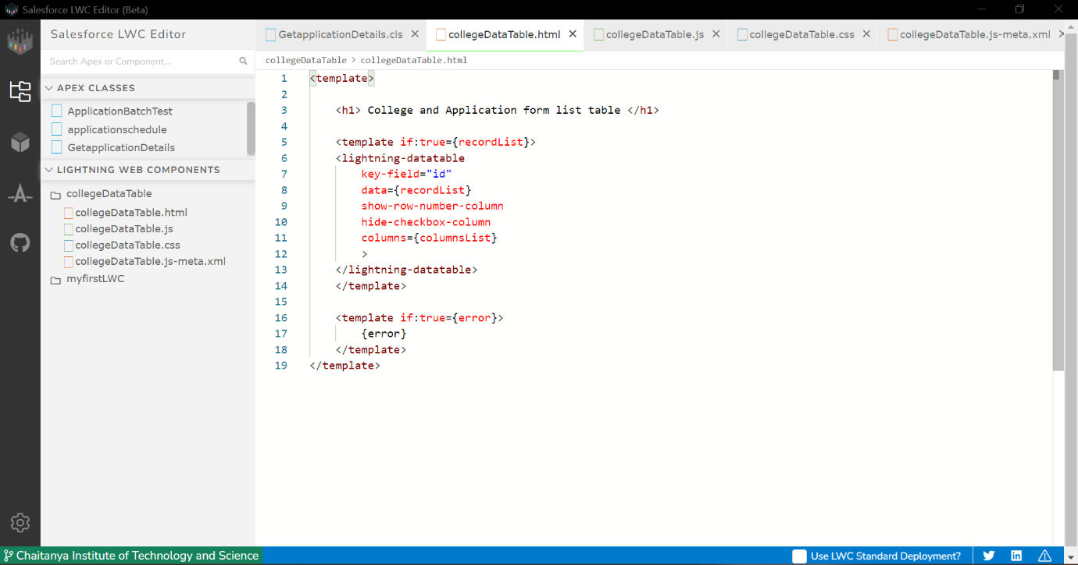

**Creating college data table component( Java Script File ) :**

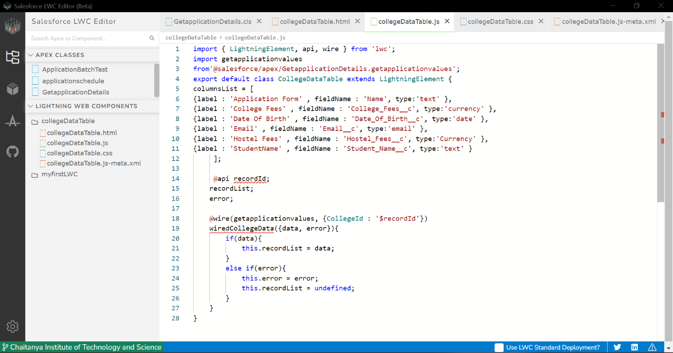

**Creating college data table component( Meta File ) :**

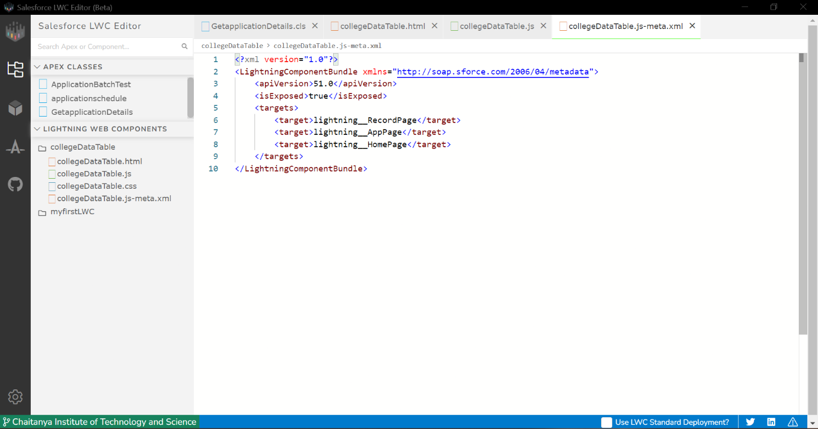

**Data table in college object :**

